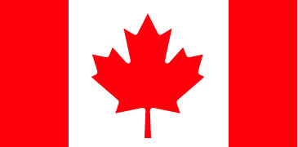 | Fisheries and Oceans  Canada | Pêches et Océans Canada

Pacific Region Région du Pacifique
Suite 200 – 401 Burrard Street Piece 200 – 401 rue Burrard
Vancouver, British Columbia Vancouver (C.-B.)
V6C 3S4 V6C 3S4

April 20, 2018

Dear stakeholder,

On September 21, 2017, Fisheries and Oceans Canada (DFO) sent letters to Indigenous groups and stakeholders informing them that 13 newly identified glass sponge reefs in Howe Sound had been brought to DFO’s attention, and that DFO had been partnering with the Marine Life Sanctuary Society (MLSS) to learn more about these sites.

In that letter, we informed you that a final report from DFO Science Branch was pending and asked fishers to voluntarily avoid fishing in these areas with bottom contact fishing gear until further research was concluded. Since that time, DFO Science has released the report: Glass Sponge Aggregations in Howe Sound: Locations, Reef Status, and Ecological Significance Assessment.

For that study, DFO Science in collaboration with Natural Resources Canada (NRCan) analysed data from MLSS and NRCan, as well as visual survey data collected by DFO Science, to get a complete assessment of glass sponge reefs’ spatial extent and status throughout Howe Sound. In doing so, DFO Science found additional reefs for a total of 18 sites. Nine of those sites require further groundtruthing to confirm their ecological significance, while nine others were deemed to have important ecological function. As such, DFO amended its request for voluntary avoidance using bottom contact fishing gear to the nine locations confirmed by DFO Science to have important ecological function through a Fishery Notice (FN0279) posted on April 6th. Voluntary avoidance of the other nine sites may be requested at a later date pending additional research.

With the release of this new Science information, DFO Fisheries Management would now like to hold a multi-stakeholder workshop in July to discuss the science findings, potential mitigation measures and draft economic analysis for these ecologically important sensitive benthic areas. If you would like to attend this workshop please identify which dates work best for you by filling in the Doodle Poll at the link here: https://doodle.com/poll/zmfthhgqfqisr75k

If you have any questions or would like further information on the Strait of Georgia and Howe Sound Glass Sponge Reef Conservation Initiative, please contact Aleria Ladwig at Aleria.ladwig@dfo-mpo.gc.ca.

Sincerely,

Aleria Ladwig
Ecosystems Approach Officer
Fisheries and Oceans Canada

Attachments:
- Map showing nine confirmed live glass sponge reefs with important ecological function; nine other sites requiring further groundtruthing; and reefs previously protected in 2014
- List of coordinates showing latitudes and longitudes of reefs where DFO is now requesting voluntary avoidance

Documents accompanying this letter:
- Stakeholder letter sent September 21, 2017 (PDF)
- DFO Science Report: Glass Sponge Aggregations in Howe Sound: Locations, Reef Status, and Ecological Significance Assessment

Map showing nine confirmed live glass sponge reefs with important ecological function; nine other sites requiring further groundtruthing; and reefs previously protected in 2014

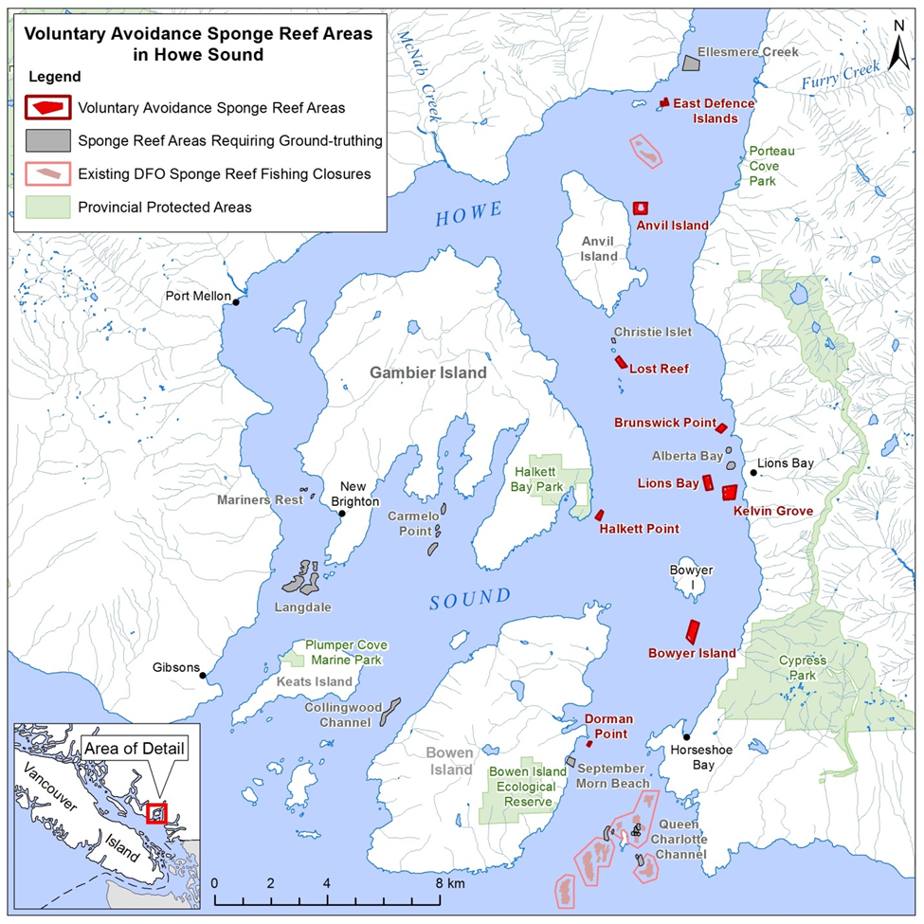
Howe Sound Voluntary Avoidance Sponge Reef Areas (4-sided polygons)

NOTE: Defense Island is broken into two small sites for management / coordinate reasons but is considered one site in the science report.
East Defence Island (West): That portion of Subarea 28-4 that lies inside a line that begins at 49° 34.716' N, 123° 16.430' W then northeast to 49° 34.717' N, 123° 16.384' W then southeast to 49° 34.633' N, 123° 16.372' W then northwest to 49° 34.641' N, 123° 16.425' W then to the beginning point.
East Defence Island (East): That portion of Subarea 28-4 that lies inside a line that begins at 49° 34.770' N, 123° 16.312' W then true east to 49° 34.770' N, 123° 16.261' W then southeast to 49° 34.647' N, 123° 16.214' W then northwest to 49° 34.648' N, 123° 16.311' W then to the beginning point.
Anvil Island: That portion of Subarea 28-4 that lies inside a line that begins at 49° 32.790' N, 123° 17.343' W then southeast to 49° 32.788' N, 123° 16.955' W then southwest to 49° 32.572' N, 123° 16.978' W then northwest to 49° 32.574' N, 123° 17.345' W then to the beginning point.
Lost Reef: That portion of Subarea 28-2 that lies inside a line that begins at 49° 29.801' N, 123° 18.059' W then northeast to 49° 29.857' N, 123° 17.957' W then southeast to 49° 29.651' N, 123° 17.737' W then southwest to 49° 29.633' N , 123° 17.885' W then to the beginning point.
Brunswick Point: That portion of Subarea 28-2 that lies inside a line that begins at 49° 28.384' N, 123° 15.181' W then northeast to 49° 28.479' N, 123° 14.987' W then southeast to 49° 28.417' N, 123° 14.870' W then southwest to 49° 28.315' N, 123° 15.038' W then to the beginning point.
Lions Bay: That portion of Subarea 28-2 that lies inside a line that begins at 49° 27.483' N, 123° 15.611' W then northeast to 49° 27.499' N, 123° 15.420' W then southeast to 49° 27.239' N, 123° 15.347' W then southwest to 49° 27.227' N, 123° 15.536' W then to the beginning point.
Kelvin Grove: That portion of Subarea 28-2 that lies inside a line that begins at 49° 27.268' N, 123° 15.047' W then northeast to 49° 27.290' N, 123° 14.639' W then southwest to 49° 27.036' N, 123° 14.715' W then southwest to 49° 27.032' N, 123° 15.037' W then to the beginning point.
Halkett Point: That portion of Subarea 28-2 that lies inside a line that begins at 49° 26.771' N, 123° 18.823' W then northeast to 49° 26.912' N, 123° 18.660' W then southeast to 49° 26.879' N, 123° 18.594' W then southwest to 49° 26.722' N, 123° 18.700' W then to the beginning point.
Bowyer Island: That portion of Subarea 28-2 that lies inside a line that begins at 49° 24.403' N, 123° 16.282' W then northeast to 49° 24.737' N, 123° 16.113' W then southeast to 49° 24.676' N, 123° 15.911' W then southwest to 49° 24.274' N, 123° 16.106' W then to the beginning point.
Dorman Point: That portion of Subarea 28-2 that lies inside a line that begins at 49° 22.485’ N, 123° 19.259' W then southeast to 49° 22.472' N, 123° 19.191' W then southwest to 49° 22.391' N, 123° 19.268' W then northwest to 49° 22.416' N, 123° 19.321' W then to the beginning point.

