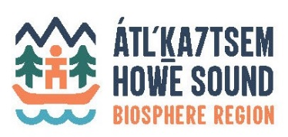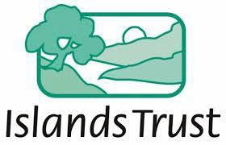

Ocean Watch Action Committee Report – May 2022 - April, 2023

Since the last HSCF in April 2022, the committee met over Zoom: June 10th, September 23rd, January 13th and April 14th. Meeting notes, plans and Action Tracker can be viewed here.

Participating organizations: Representatives of the Howe Sound Community Forum member communities- Town of Gibsons, District of West Vancouver, District of Squamish, Bowen Island Municipality, Gambier Island Local Trust Committee, Area A Metro Van, SLRD, MLA Sturdy’s office, Squamish Nation, David Suzuki Foundation, Marine Stewardship Initiative, Squamish River Watershed Society, Howe Sound Biosphere Region Initiative Society

Organizer & Moderator: Ruth Simons, Executive Director, Howe Sound Biosphere Region Initiative Society (HSBRIS)

Objectives of the Committee – Terms of Reference:
- Learn and build consensus on collective actions Local Governments can take to advance Ocean Health.
- Advance actions emerging from Átl’ḵa7tsem/Txwnéwu7ts/Howe Sound Edition 2020 (OWHS 2020)
- To review and share updates on each of the recommended actions and strategic plan.

Activities and major actions resulting since April 2022 report:
- Introduction to newly elected Council members now participating on the committee.
- Monitoring, restoration and funding actions taking place around the sound added to the Ocean Watch Action Tracker. A few highlights:
  - Marine Reference Guide received an Esri Canada top spot in their calendar.
  - Herring surveys continue with this winter’s spawn recorded at 5 kms long.
  - Re-commencement of Rockfish monitoring by Marine Life Sanctuaries Society

- Education and presentations received on:
  - Fisheries and Oceans Canada – Howe Sound Glass Sponge Reef, Rockfish Conservation area alignment and education.
  - Átl'ka7tsem/Howe Sound Nchu'ú7mut/Unity Plan – HSBRIS
  - West Coast Environmental Law’s Marine Protected Area Project
  - UBC Institute for Fisheries and Oceans – eDNA sampling for key species

Collaborative Actions:
- Metro Vancouver barge sharing in Howe Sound Marine Debris clean-up and cooperation with Marine Stewardship’s Marine Debris Coordinator and the development of the Debris Tracker tool.
- Increased locations at the entrance of Howe Sound for Green Crab Monitoring - Invasive Species Council
- Participation at the Fisheries and Oceans workshop on GSA and RCA alignment

Recommendations to HSCF:
- To support the establishment of a Marine Debris Fund to cover the costs incurred by local stewards for handling and removal of marine debris. The fund would fill a gap in the absence of any other available funding. More information to follow.

Note Takers: Bridget John, Research Assistant, Marine Reference Guide (MRG) & Diane Mitchell, HSBRIS

Renewed Financial support from: Islands Trust for Secretariate Services.
For more information contact howesoundbri@gmail.com www.howesoundbri.org/marine- action-network

