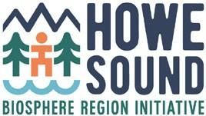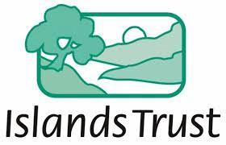

Ocean Watch Action Committee Report - November - April, 2022

Since the last HSCF, the committee met: January 14 and March 25. Meeting notes, plans and Action Tracker can be viewed here.

Participating organizations: Representatives of the Howe Sound Community Forum member communities- Town of Gibsons, District of West Vancouver, District of Squamish, Bowen Island Municipality, Islands Trust, Area A Metro Van, SLRD, MLA Sturdy’s office, Squamish Nation, David Suzuki Foundation, Marine Stewardship Initiative, Squamish River Watershed Society, Howe Sound Biosphere Region Initiative Society

Organizer & Moderator: Ruth Simons, Executive Director, Howe Sound Biosphere Region Initiative Society (HSBRIS)

Objectives of the Committee – Terms of Reference:
- Learn and build consensus on collective actions Local Governments can take to advance Ocean Health.
- Advance actions emerging from Átl’ḵa7tsem/Txwnéwu7ts/Howe Sound Edition 2020 (OWHS 2020)
- To review and share updates on each of the recommended actions and strategic plan.

Activities since October 2021 report:
- Zoom meetings were well attended in January and March.
- Monitoring, restorations and funding actions added to the Ocean Watch Action Tracker.
- Education and presentations received on:
  - Fisheries and Oceans Canada - Strait of Georgia and Howe Sound Glass Sponge Reef Initiative
  - Green Crab Monitoring - Invasive Species Council
  - Átl'ka7tsem/Howe Sound Nchu'ú7mut/Unity Plan - HSBRIS
- The transition of the Marine Reference Guide to Marine Stewardship Initiative
- Planning for Howe Sound Marine Debris clean-up and cooperation.

Recommendations to HSCF:
- Renewed support for the Principles for Cooperation, ongoing forums and Ocean Watch Action committee.
Note Taker: Bridget John, Research Assistant, Marine Reference Guide (MRG)
Renewed Financial support from: Islands Trust for Secretariate Services.

For more information contact howesoundbri@gmail.com www.howesoundbri.org/marine-action-network

